HEURISTIC EVALUATION

**GIVA jewellery:**

*GIVA’S jewellery is stylish and modern,it also include tradetional designs.Their collections includes rings,necklaces,earings,bracelets,anklets,and even personalized jewellery.They offers jewellery at affordable prices compared to many other permimun brands.*

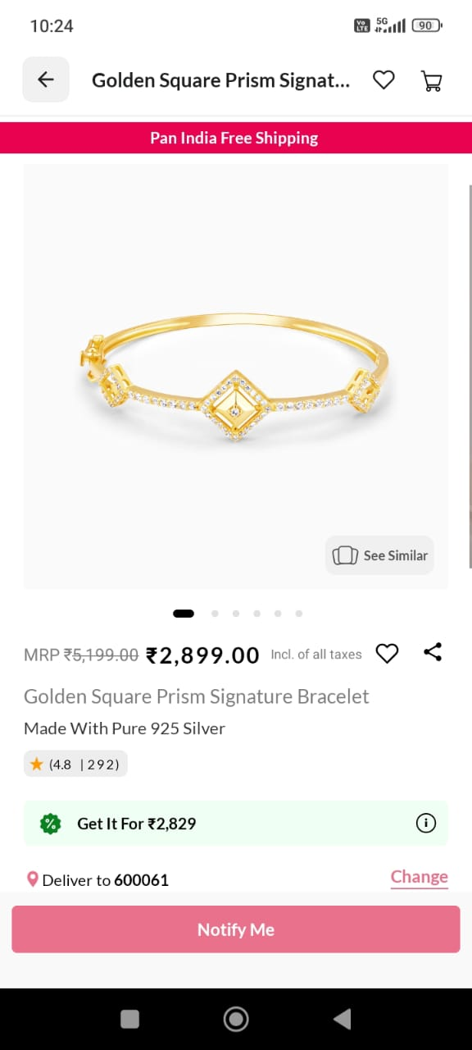

**VISIBILITY OF SYSTEM STATUS:**

ISSUE:

Users only find out a product is out of stock after

clicking on it, which wastes time and can be

frustrating. Even though there is a notify

option, users may still feel irritated because

they expected the items to be available.

SOLUTION:

Show out of stock directly on the product image or listing. Disable the add to cart button for out-of-stock items.

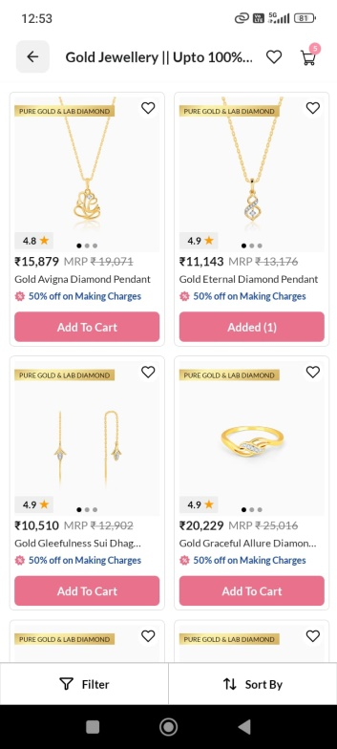

**MATCH BETWEEN SYSTEM AND THE REAL WORLD**:

ISSUE:

GIVA uses unrelated icons in the payment options. The wallet icon and the card icon look the same. They don’t use a proper wallet icon for wallet options, so both look identical.

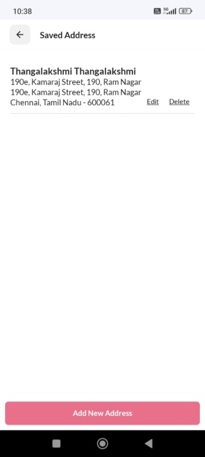

SOLUTION:

Design the wallet icon to look like a real wallet and design the card icon to resemble a real credit/debit card.

**USER CONTROL AND FREEDOM:**

NO PROBLEM:

User can easily remove items from their cart, undo actions, and go back to previous steps. The return /exchange process is clear.

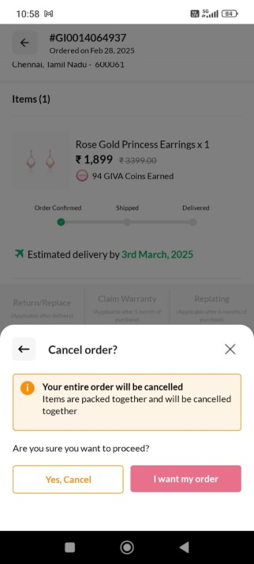

**ERROR PREVENTION:**

ISSUE:

Review: Users can only add reviews after purchasing the product , but there is allowing anyone to submit a review, even if they haven’t bougth the product

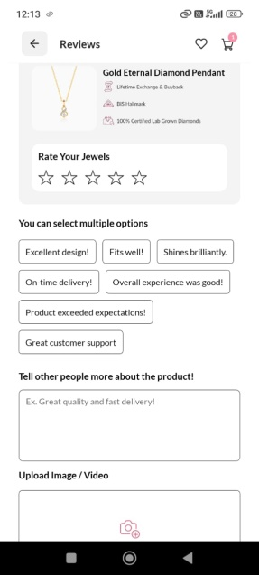

SOLUTION:

A good solution is to allow only verified buyers to submit reviews.

**RECOGNITION RATHER THAN RECALL:**

NO PROBLEM

The search box provides suggestions to users white type half a word of an item, saving their time.

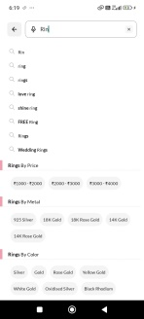

**FLEXIBILITY AND EFFICIENCY OF USE:**

NO PROBLEM:

Quick filters and sorting options help users find products efficiently. The system offers sortcuts like wishlist.

**AESTHETIC AND MINIMALIST DESIGN:**

NO PROBLEM:

It highlights important actions like searching a items, viewing a offers, ratings can focus on their goals without distractions.

**HELP USERS RECOGNISE, DIAGNOSE, AND RECOVER FROM ERRORS:**

**NO PROBLEM:**

The error text which appears while failed loading and attempts.

**HELP AND DOCUMENTATION:**

NO PROBLEM:

Giva provides “help and support” for users to seek help when needed easily and within app itself.